**Name: Sanio Luke Sebastian**

**Roll No: 35**

**Batch: B**

**Date: 24-03-2022**

**NETWORKING & SYSTEM ADMINISTRATION LAB**

**Experiment No.: 2**

**Aim**

Familiarization of Linux Commands.

**Procedure**

1. **pwd:** It is used to get the current directory path.

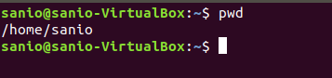

1. **mkdir:** ‘mkdir foldername’ creates new directory in the current location.

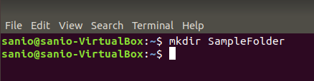

1. **man:** This command helps you with the description of a specified mentioned command.   
   E.g., ‘man pwd’.

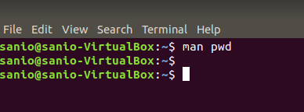

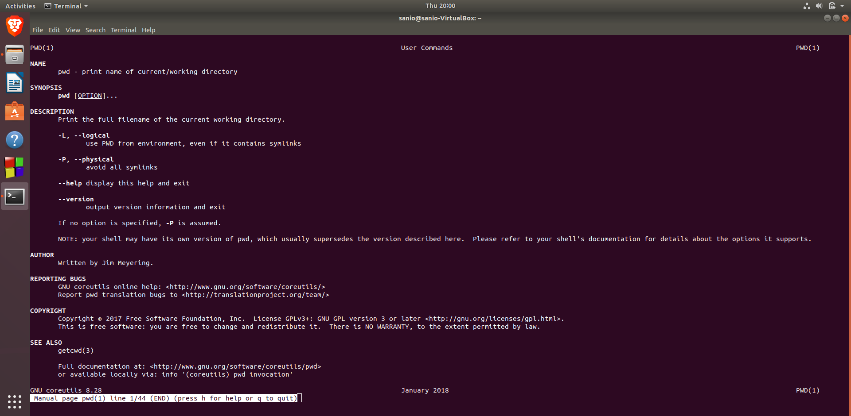

1. **ls:** ‘ls’ command shows the list of all the files & folders of the current location/directory.

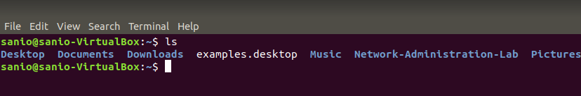

* 1. **ls -l:** This variant of the ‘ls’ command is used to describe all the files about their properties and their states.

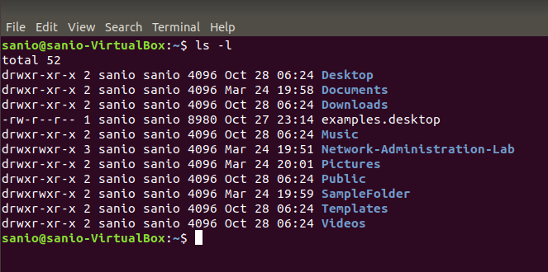

* 1. **ls -r:** This type helps to display the list of the available files and folders in a reverse order.

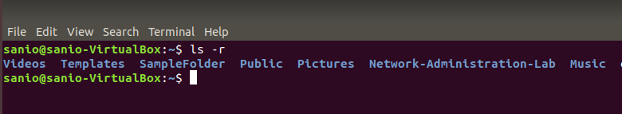

* 1. **ls -a:** This command lists all the hidden files and folders along with the normal files & folders in the current directory.



* 1. **ls -A:** This helps to list down all the hidden files and folders except the “.” and “..” folders.



* 1. **ls -t:** This command helps to list out the folders and files according to the order of the newly modified files and files within the folders.

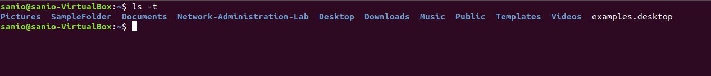

1. **cd:** This simple command helps to go back to home directory.

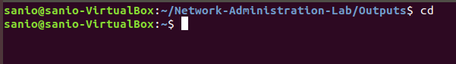

* 1. **cd ‘path’:** This variation is used to change current directory to another directory using the mentioned path.

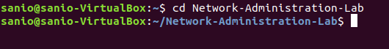

* 1. **cd - :** These helps to move back to the previous stated directory.



* 1. **cd .. :** This simple command helps to go one directory back if exists.

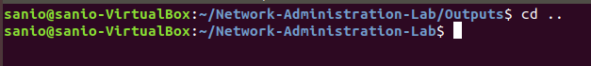

1. **cat:** The ‘cat’ command is used to print the entered text in the terminal itself.

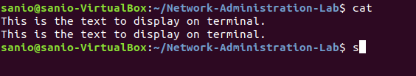

* 1. **cat > ‘filename’:** This type is used to create filename and write data within the file.   
     E.g., cat file1.txt.

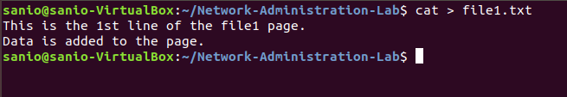

* 1. **cat >> ‘filename’:** This command helps to append the entered data to the mentioned file.

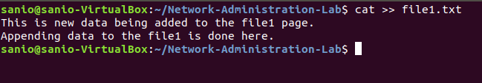

* 1. **cat ‘filename’:** The commands is used to print the data within the mentioned file which is in the current directory. If such file doesn’t exist, then the command creates an empty file with that name.

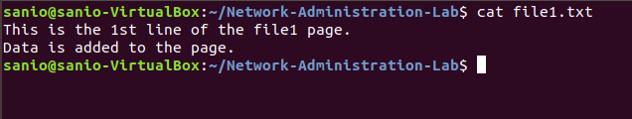

* 1. **cat ‘file1 name’ > ‘file2 name’:** This command helps you to copy the data from a file to another file.

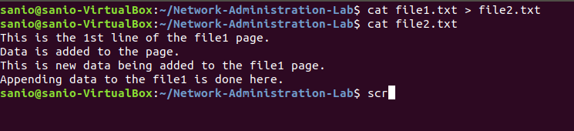

* 1. **cat ‘file1 name’ >> ‘file 2 name’:** This type helps to append whole data of a mentioned file and to another mentioned file.

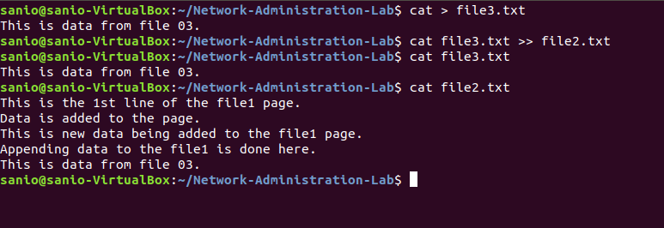

* 1. **cat -n ‘filename’:** Prints the contents of the mentioned file along with the numbers to the contents according the no. of lines.

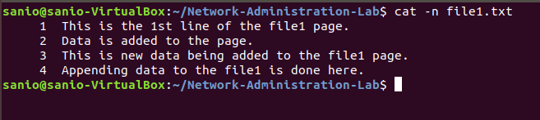

* 1. **cat -b ‘filename’:** This command prints the counted no. of the lines along with the numbers avoiding the black space new lines with the count.

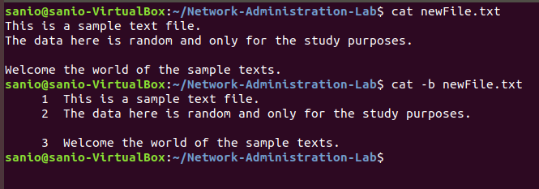

1. **echo ‘contents’:** Prints the contents mentioned along with the command to the terminal.

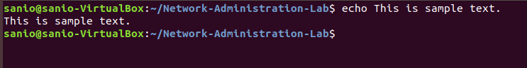

* 1. **echo ‘contents’ >> ‘filename’:** This command also adds/appends the mentioned contents to the mentioned file just like the “variation of cat command”.

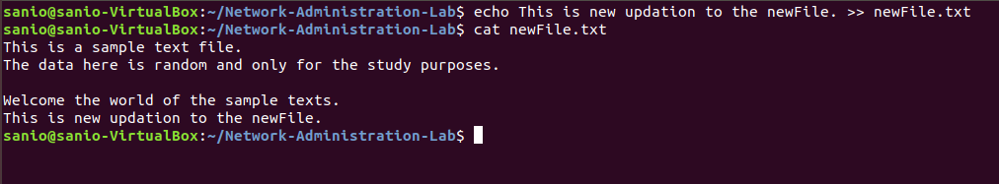

1. **touch ‘new filename’:** Creates a new file according to the mentioned name.

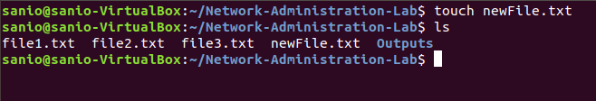

1. **head ‘filename’:** Prints the first starting 10 lines (default) onto the terminal.

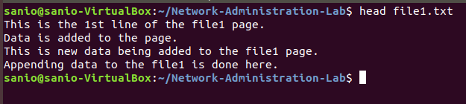

* 1. **head –‘n’ ‘filename’:** The prints the starting ‘n’ no. of lines onto the terminal.

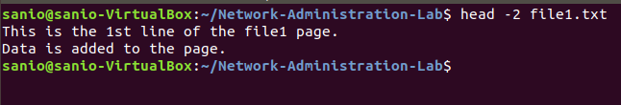

1. **tail ‘filename’:** Prints the first last 10 lines (default) onto the terminal.

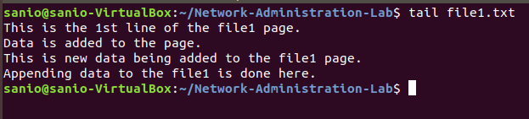

* 1. **tail -‘n’ ‘filename’:** The prints the last ‘n’ no. of lines onto the terminal.

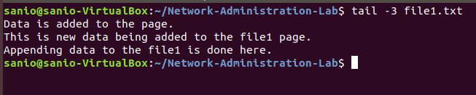

1. **cut -d’delimiter’ -‘f(n)’ ‘filename’:** This command is used to cut the specified portion of the mentioned file with the help of mentioned delimiter/character and also along with the specified column number ‘n’ that is formed after the splicing the contents into ‘m’ no. of columns of data using the delimiter and finally printing it to the terminal console.  
   **E.g., cut -d- -f2 file1.txt**

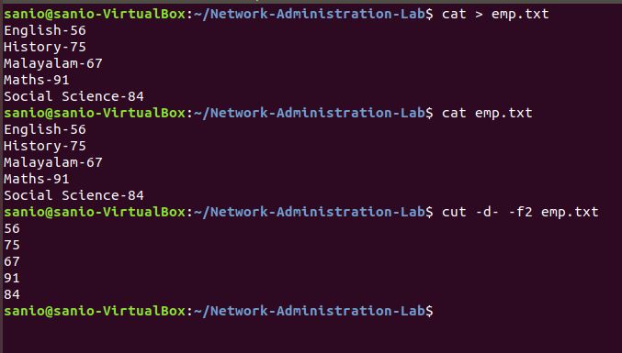

1. **rmdir ‘filename’:** Removes/Deletes the mentioned directory. (In order to delete, the mentioned directory should be an empty directory.)

